Project: Test Plan
Course: CSD380 - DevOps
Description: Todo app testing.
Date: 2026/01/14
To complete the test case plan, fill out the information for Project, Course, Description and Date in the header below.
.
TABLE OF CONTENTS
<DESCRIPTION> 2
<DESCRIPTION> 2
<DESCRIPTION> 3

For each test, the developer should: provide a test description, a test objective, the developer name and date tested. For each step, fill out the actions to be taken and describe the expected results, and indicate yes or no for each step depending upon the result. The peer tester should provide their name, date tested, indicate yes or no for each step depending upon the result, and a screenshot (thumbnail) of the result.

Test 1 | EXAMPLE #1 (IGNORE) Access
 | Test Objective: Verify that users can access the website through a standard URL. | Developer:  Date tested: N/A | Peer tester: Brennan Cheatwood  Date tested: 2026/01/14
Step | Action | Expected results: | Developer pass/fail | Tester pass/fail  + Screenshot
1 | Visit https://buwebdev.github.io/todo/ | Confirm the page loaded without errors. | N/A | YES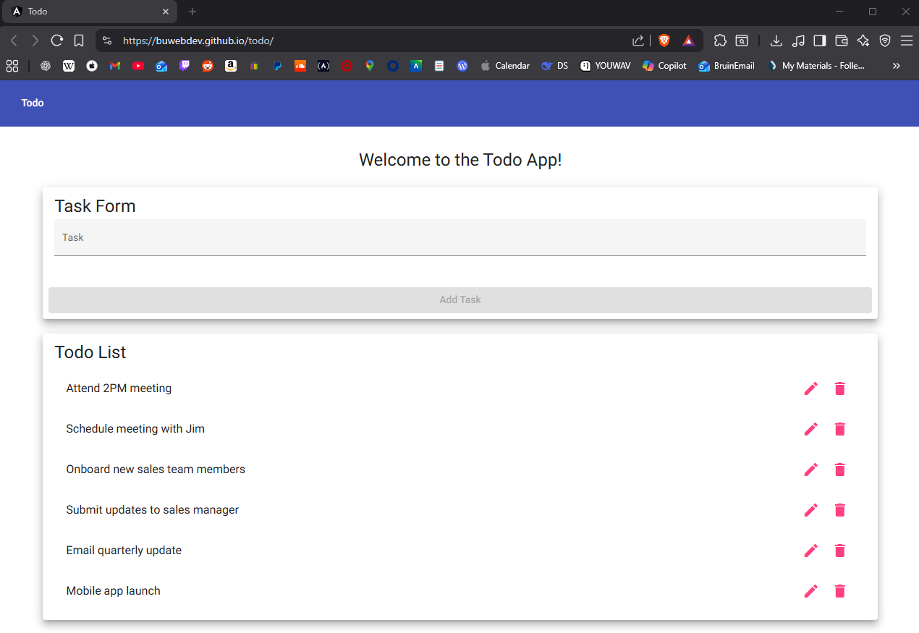
2 | Refresh the browser window. | Confirm the page reloaded correctly. | N/A | YES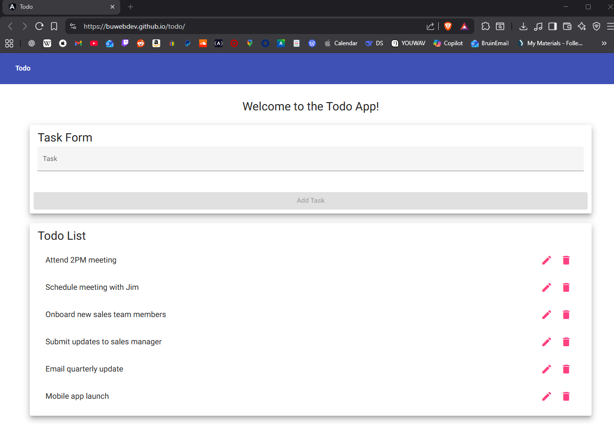
3
4
5
Comments | This was the given example #1 from the assignment.

Test 2 | Functional Requirements
 | Test Objective: Ensuring the Todo app functions as intended by the given requirements. | Developer:  Date tested: N/A | Peer tester: Brennan Cheatwood  Date tested: 2026/01/14
Step | Action | Expected results: | Developer pass/fail | Tester pass/fail
1 | Create a new todo task item. | Click on “task” input bar and enter desired task; the task will be added to the Todo List. | N/A | Pass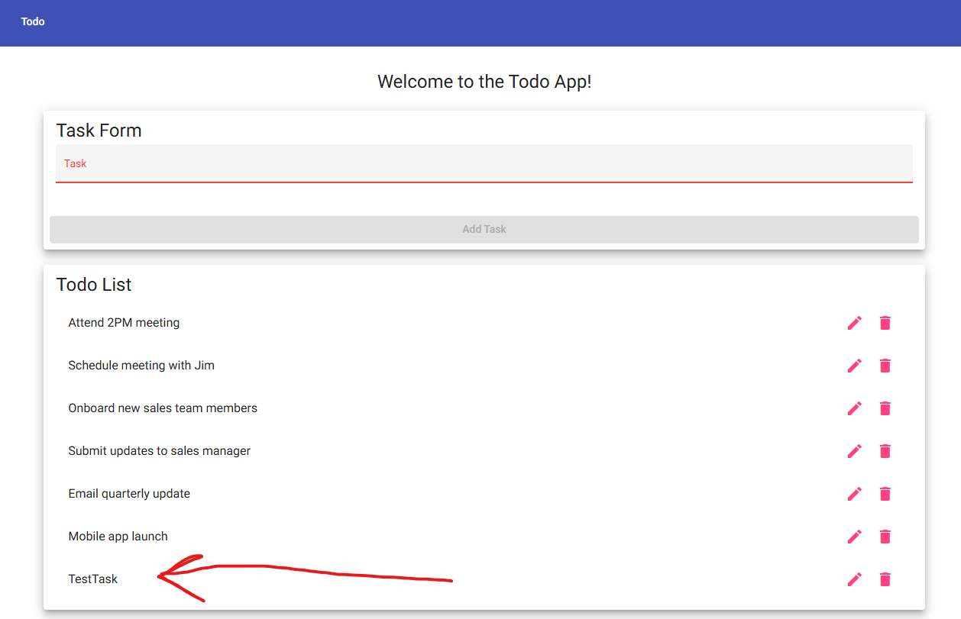
2 | Edit a todo task item. | A dialogue window appears to change the desired task; once edited, the updated text will be applied. | N/A | Pass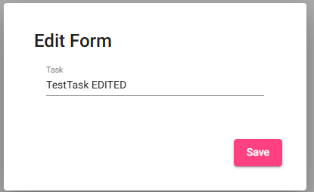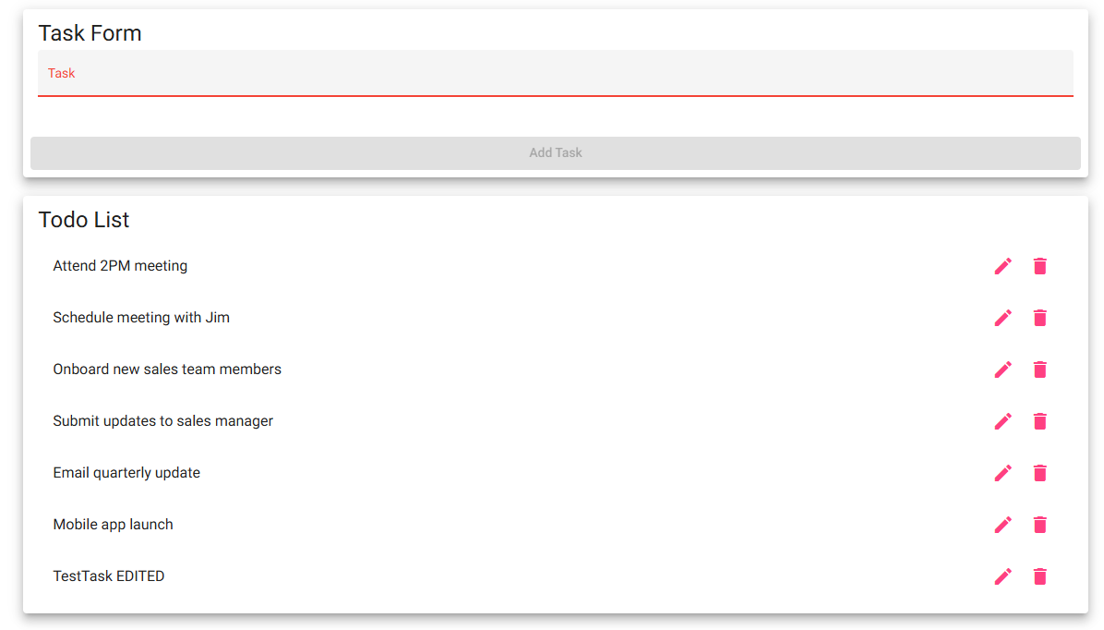
3 | Delete a todo task item. | The selected task will be removed from the list once the trash icon is clicked. | N/A | Pass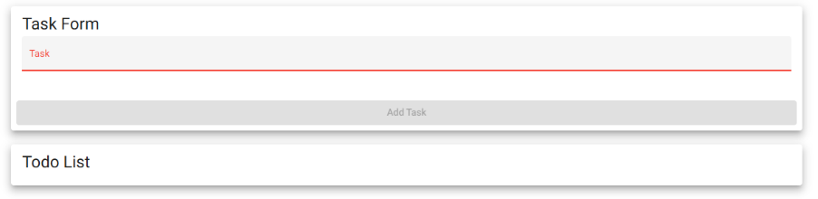
4 | Prevent users from submitting a task form without entering a todo item. | The “Add Task” button should be greyed out until the user inputs a task. | N/A | Pass
5 | Provide users with a view for mobile devices. | Once the window is shrunken to mobile-view, the website should dynamically shift to fit on mobile devices. | N/A | Pass + Verified on mobile phone. 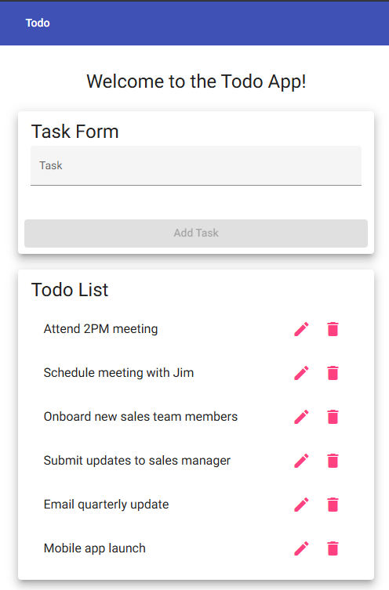
Comments | 5 requirements out of the given 10 are completely functional through my testing. There were absolutely no errors when conducting this test.

Test 3 | <DESCRIPTION>
 | Test Objective: | Developer:  Date tested: <yyyy/mm/dd> | Peer tester:  Date tested: <yyyy/mm/dd>
Step | Action | Expected results: | Developer pass/fail | Tester pass/fail
1 | <Enter an action> | <Enter the expected results> | <yes/no> | <yes/no>
2 | <Enter an action> | <Enter the expected results> | <yes/no> | <yes/no>
3 | <Enter an action> | <Enter the expected results> | <yes/no> | <yes/no>
4 | <Enter an action> | <Enter the expected results> | <yes/no> | <yes/no>
5 | <Enter an action> | <Enter the expected results> | <yes/no> | <yes/no>
Comments | Comments should be substantive; this means there should be at least 2-3 well-structured sentences with constructive feedback.

